
Lesson 5 Teacher's Key
Scratch
INSTRUCTOR ONLY - do not distribute to students

Level 1 - Complete Worked Solution
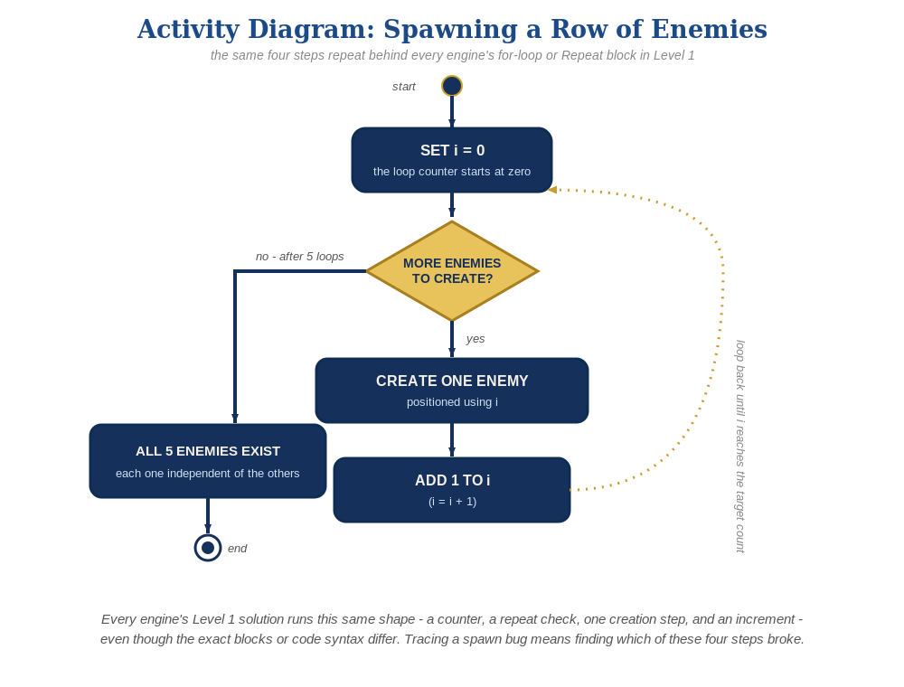
The spawn loop, in general - the same counter, repeat check, creation step, and increment behind Level 1 in every engine, whatever the exact blocks or syntax look like.
A spawn script and a clone script on the Enemy sprite, plus a reverted (simpler) Bullet script - the hit-check moves onto the Enemy this week:
-- Enemy sprite:
when green flag clicked
hide
when green flag clicked
set [enemy_number] to 0
repeat 5
change [enemy_number] by 1
set [enemy_x] to ((enemy_number * 100) - 300)
create clone of [myself]
when I start as a clone
show
go to x: (enemy_x) y: 150
forever
if <touching [Bullet]?> then
delete this clone
-- Bullet sprite (back to Lesson 3's version - no Enemy check):
when I start as a clone
show
go to x: (Player's x) y: (Player's y)
forever
change y by 10
if <y position > 170> then
delete this clone

Level 2 - Complete Worked Solution
Scratch clones have no unique ID, so a Bullet clone can't identify exactly which Enemy clone it's touching from the Bullet's side - that's why the check moved to each Enemy clone's own script, which only ever asks about itself. This already scales correctly to any number of enemies with no extra code, and a hit bullet simply isn't deleted early - it keeps moving and cleans itself up off-screen exactly like a miss.

Level 3 - All Worked Solutions
Every stretch-goal idea from the handout, fully worked - not just one. Useful for validating each idea actually works before class, and as a ready reference no matter which one a student ends up picking.

Sound: already works
If sfx_hit.wav was added to the Enemy's clone script in Lesson 4, it already plays correctly per-clone with zero changes needed this week:
when I start as a clone
show
go to x: (enemy_x) y: 150
forever
if <touching [Bullet]?> then
start sound [sfx_hit]
delete this clone

Visual: striped row
Alternate a color effect based on whether enemy_number is even or odd, right before creating each clone. Reminder for class: Scratch's color effect is a 0-200 hue dial, not an RGB color - a value like 50 just rotates the sprite's hue about a quarter of the way around the color wheel (roughly red toward yellow-green on a red sprite), so this produces "every other enemy looks noticeably different," not two specific named colors:
when green flag clicked
set [enemy_number] to 0
repeat 5
change [enemy_number] by 1
set [enemy_x] to ((enemy_number * 100) - 300)
create clone of [myself]

Structure: spawn vs. behavior stay separate
The green-flag spawn script's only job is creating clones and setting their starting enemy_x - all hit-detection and hide-on-hit logic stays inside the "when I start as a clone" script. This is what let the Sound idea above keep working with zero changes.

Complete Level 3 solution (all 3 goals combined)
Everything above combined, across the Enemy and Bullet sprites:
-- Enemy sprite:
when green flag clicked
hide
when green flag clicked
set [enemy_number] to 0
repeat 5
change [enemy_number] by 1
set [enemy_x] to ((enemy_number * 100) - 300)
create clone of [myself]
when I start as a clone
show
go to x: (enemy_x) y: 150
forever
if <touching [Bullet]?> then
start sound [sfx_hit]
delete this clone
-- Bullet sprite:
when I start as a clone
show
go to x: (Player's x) y: (Player's y)
forever
change y by 10
if <y position > 170> then
delete this clone

